 

## MARWADI UNIVERSITY

**Marwadi University**

affiliated with MU

A

**IWT Report** On

**“MUIIR PORTAL”**

prepared as a part of the requirements for the subject of

PROJECT I

B. Tech , Semester – IV

(Information & Communication Technology)

Submitted by Group:

Sr. Name of student Enrollment No

|  |  |
| --- | --- |
| (2) Hasti Hajipara | (92100133052) |

Dr. Amit Sata Sir

(Faculty Guide)

Prof. Chandrasinh Parmar

Head of the Department

Academic Year (2022-2023)

MUIIR Portal

**ABSTRACT**

MUIIR Portal is a centralized platform designed for the Marwadi University Innovation, Incubation and Research Center. The portal aims to manage all the activities and events of the center, including affiliations with different companies, start-ups, and intellectual property rights such as copyrights, designs, and trademarks. It also manages various facilities like prototype and infrastructure, and provides services like 3D printing and laser engraving.

The portal is equipped with separate dashboards for admins, students, and mentors to effectively manage all the activities. Admins have the authority to control and oversee all the activities, assign mentors, and allocate students to specific mentors. The platform streamlines the communication process between students and mentors and helps in the smooth functioning of the center.

Overall, the MUIIR Portal is an efficient tool that centralizes and manages all the activities of the Innovation, Incubation and Research Center, thus creating a seamless and effective environment for the students, mentors, and administrators.

**ACKNOWLEDGEMENT**

We would like to express our deepest appreciation to all those who provided us the possibility to complete this report. A special gratitude we give to our project Guide, Dr. Amit Sata Sir, their contribution, encouragement and suggestions, helped us to complete our project work especially in writing this report.

We have to appreciate the guidance given by other supervisor and we are also thankful to Prof. Chandrasinh Parmar Sir

**Hasti Hajipara**

**Outputs:**



Here, you can find all the details about the center's events, facilities, services, and outcomes.We have included a video that showcases the MUIIR Center and its facilities. You can also find information about the center's objectives and achievements.

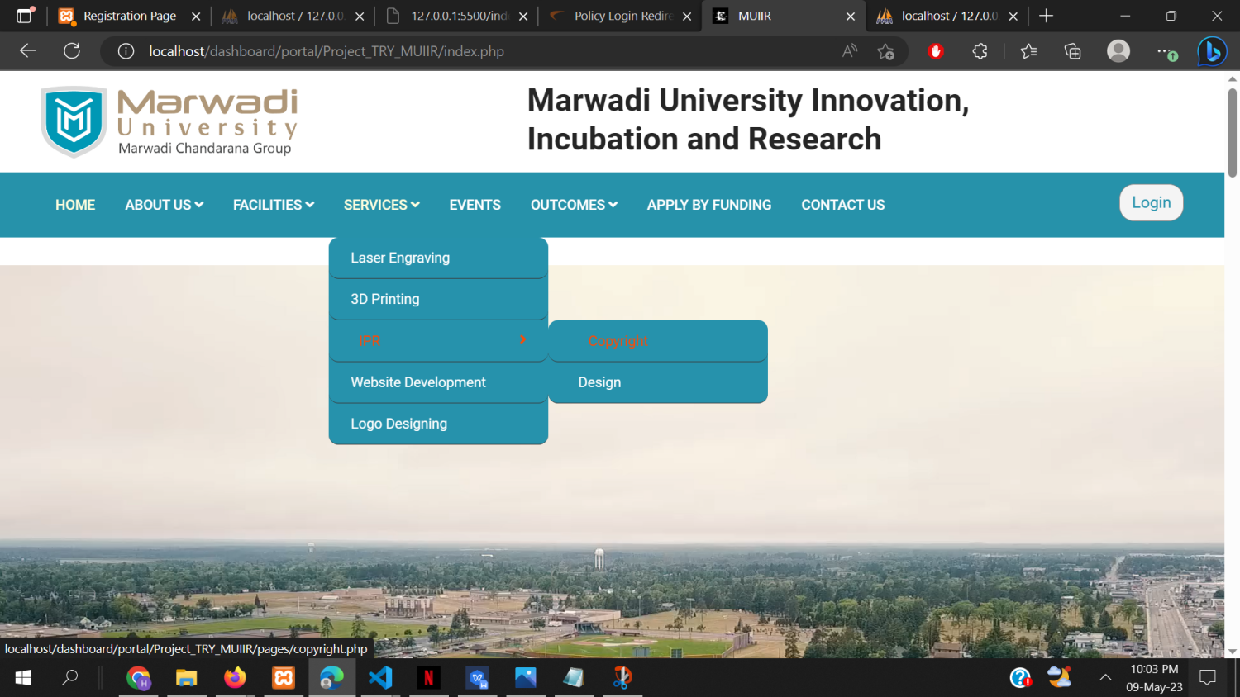

Here, you can find all the information about copyrights and how to register for them.If you are a student and want to register for copyright, you need to fill out the form below. The form includes a dynamic table option for the inventor, where you can input the necessary information. Additionally, you will need to fill out other required fields before submitting the form.

Once you submit the form, it will be reviewed and processed by the admin. The admin will verify the information and ensure that all necessary details are included. You will be notified of the copyright registration once it is approved.

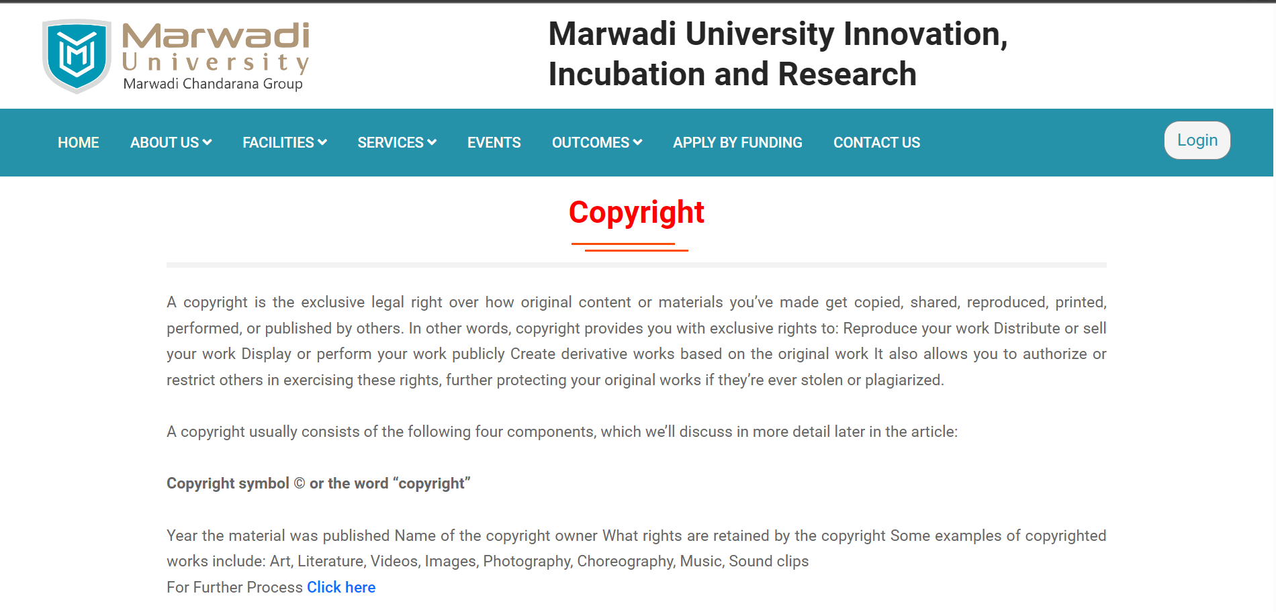

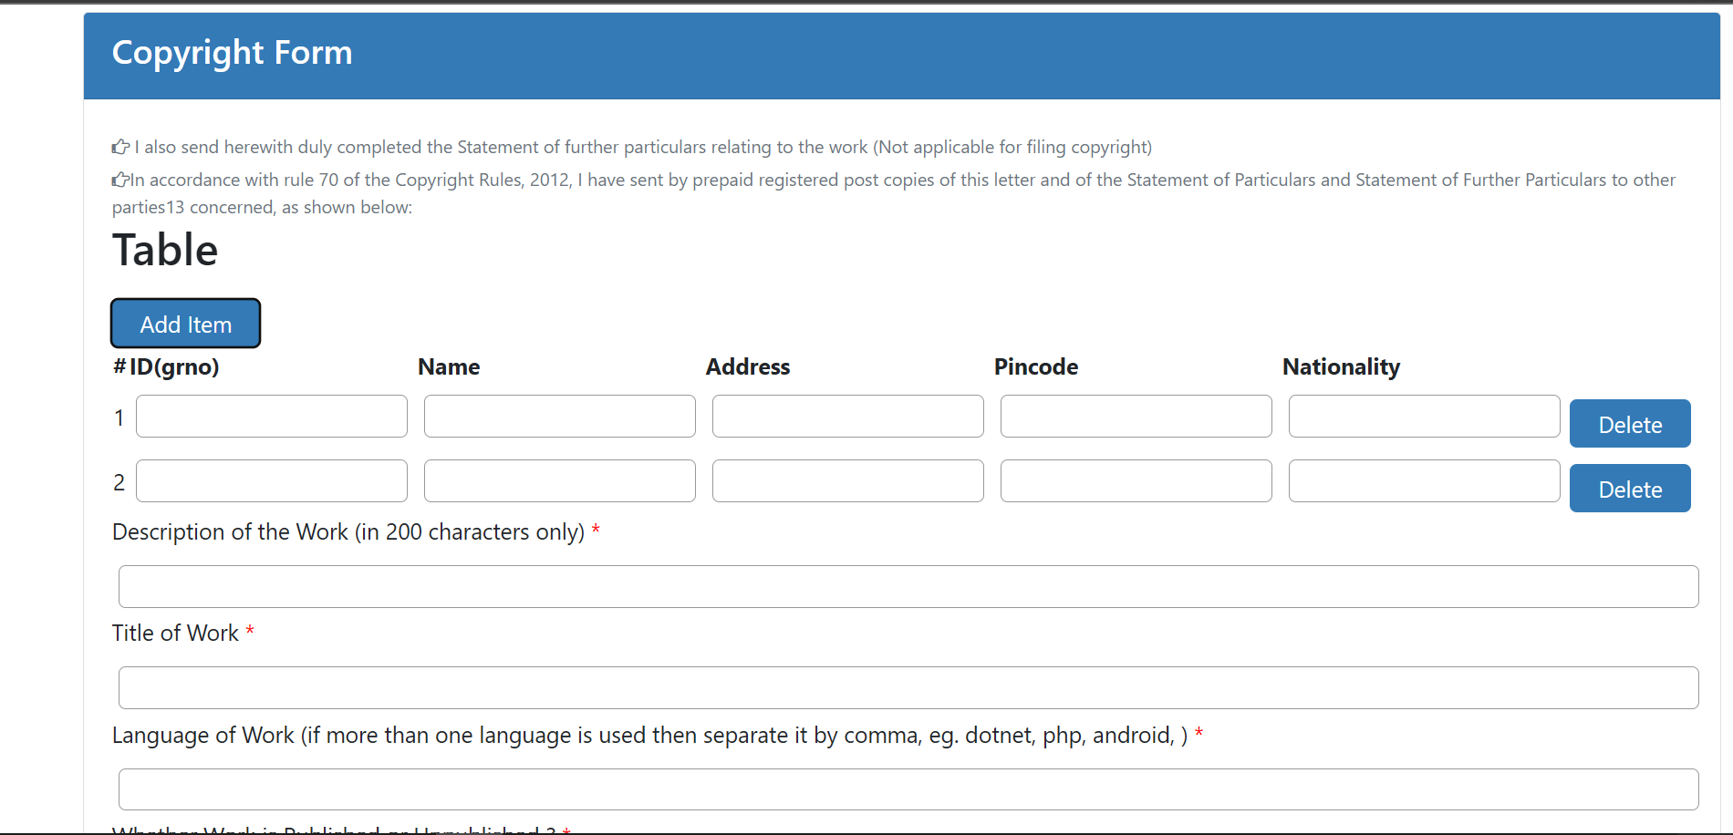

This is Prototype page which shows different type of prototype.

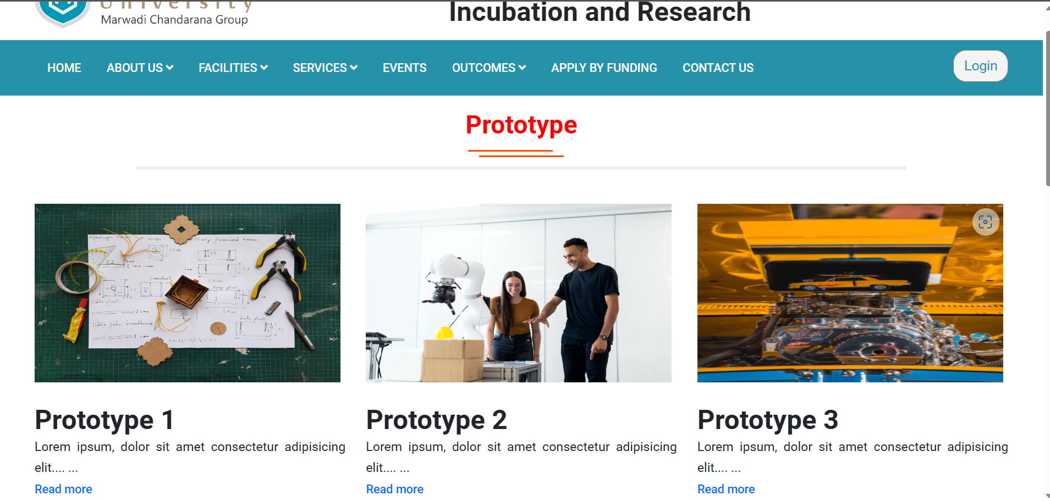

Affiliation inserted by admin



Latest top 3 Event with auto scroll



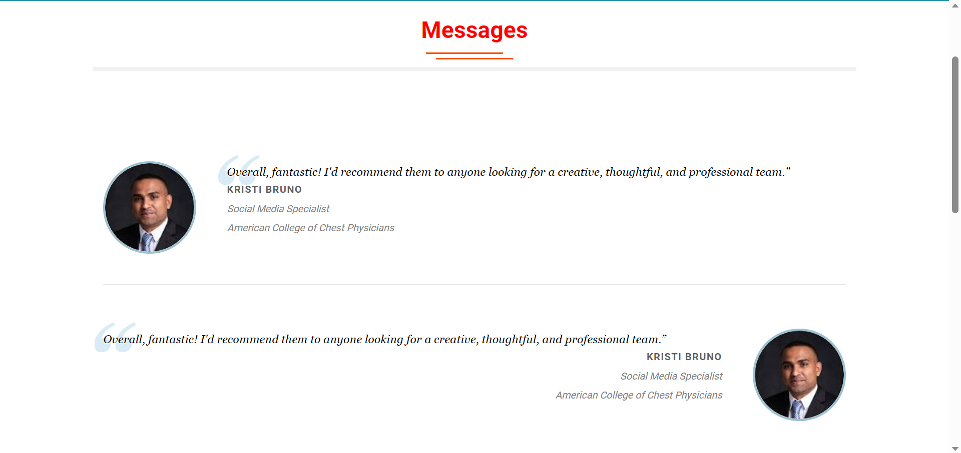

Contact us Page:

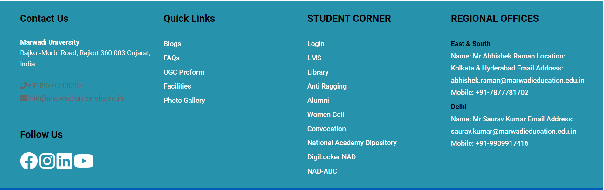

Registration Form with Proper validation:

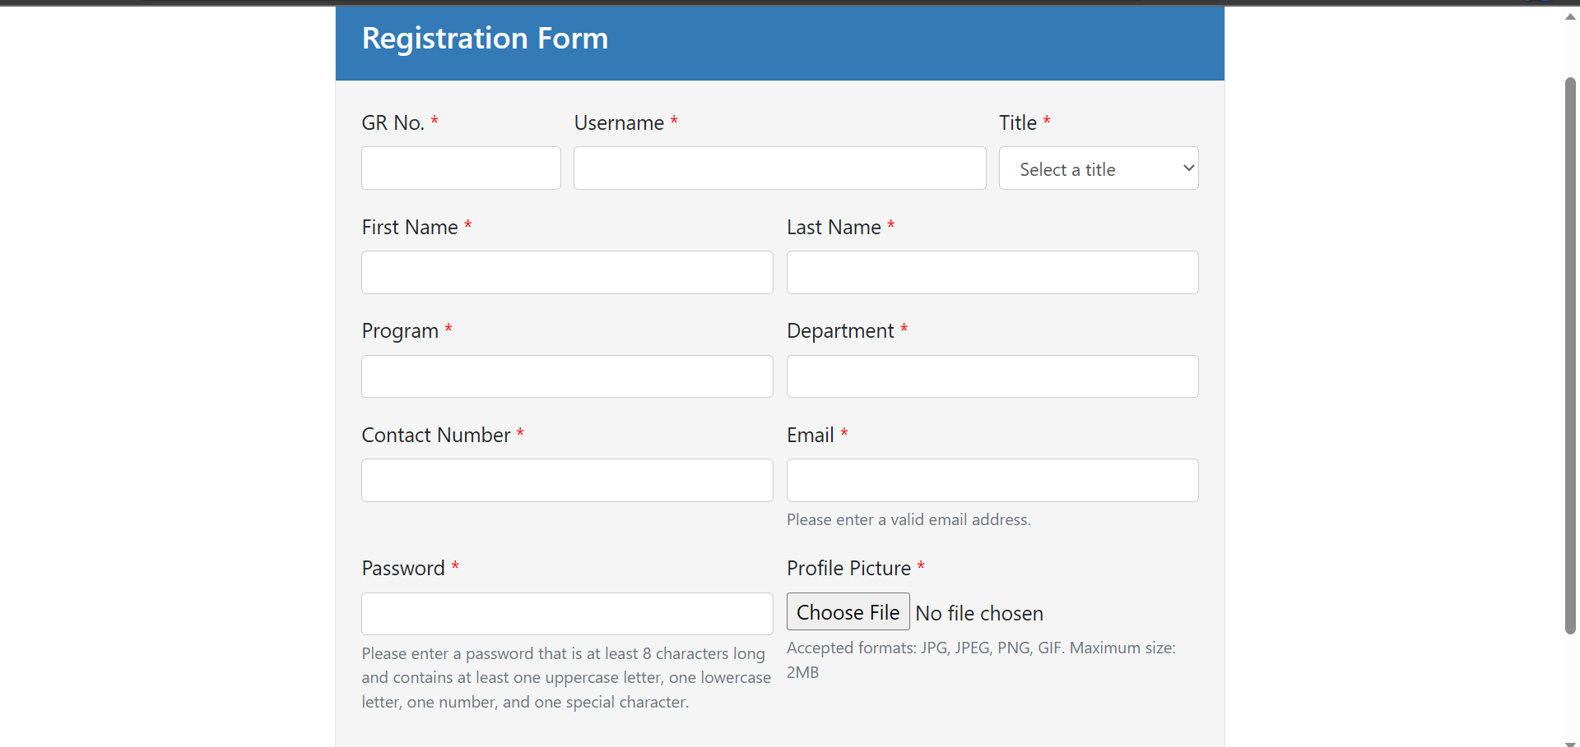

Login form for user admin and mentors:

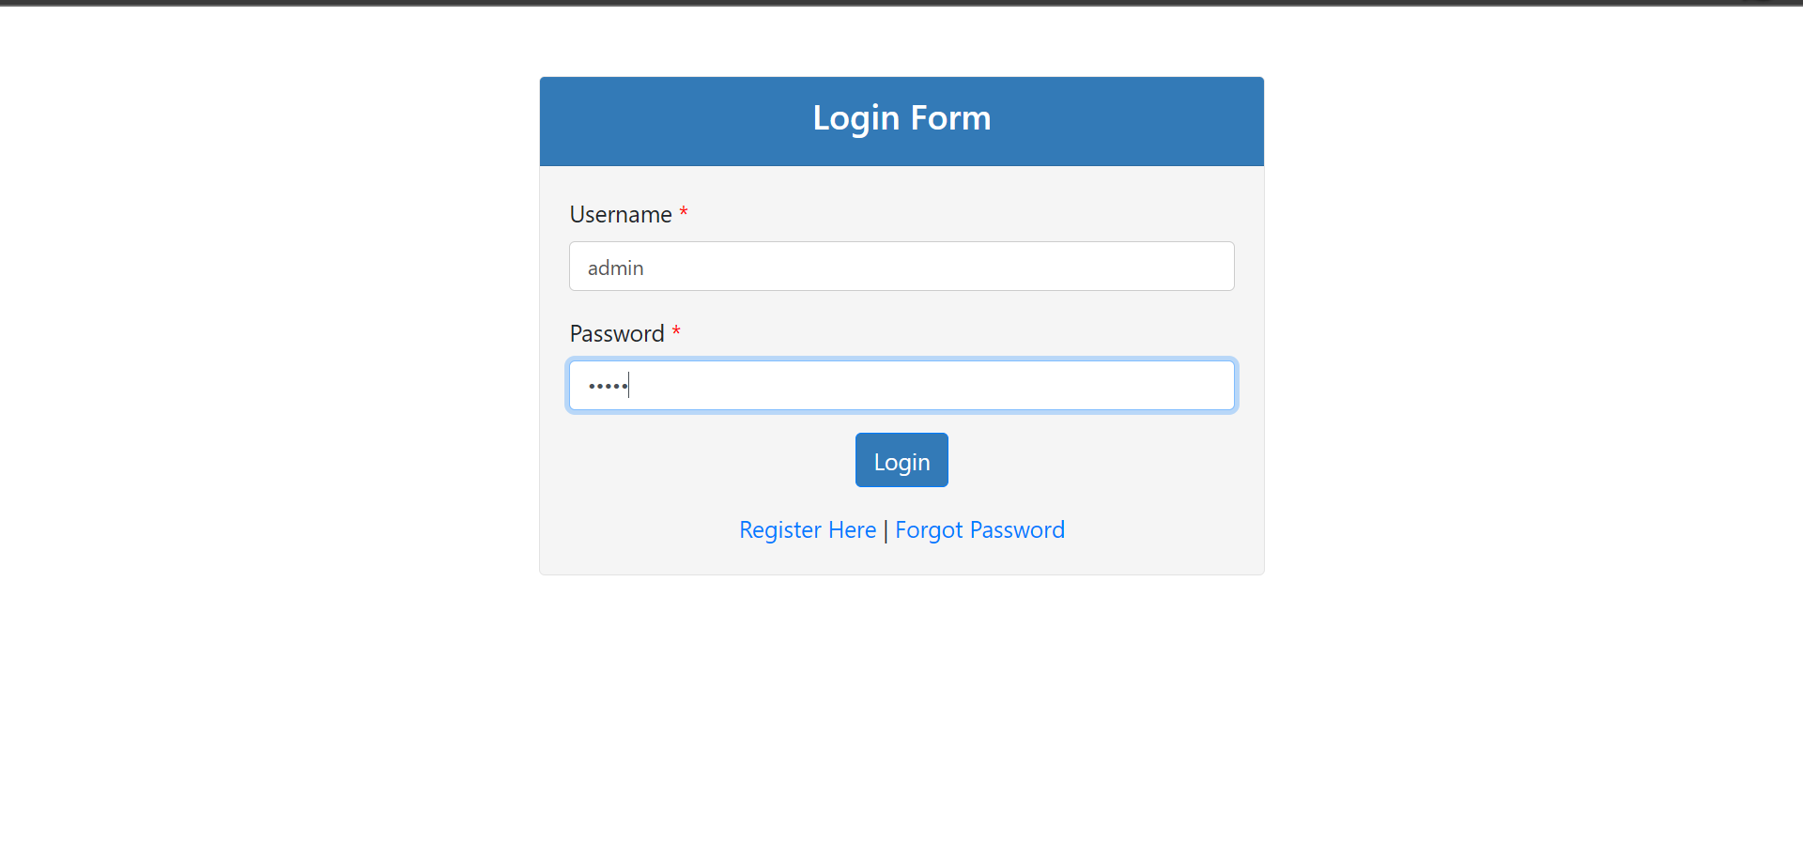

Admin Dashboard:

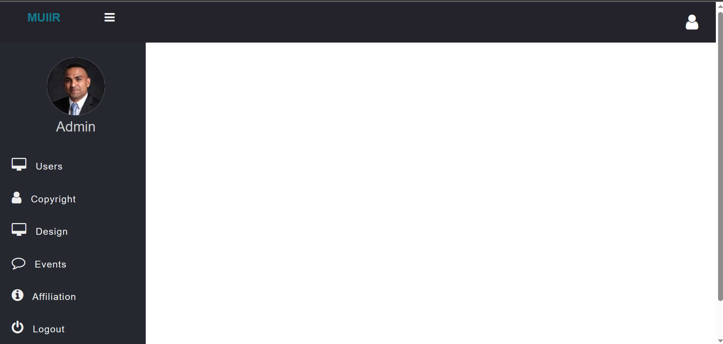

User details with CRUD Operation and Assign Mentor form the user by changing status column to 1 assign admin to change status column to 2 and 0 for students and assign students to mentor using assign Mentor form which have live search option by grno of student.

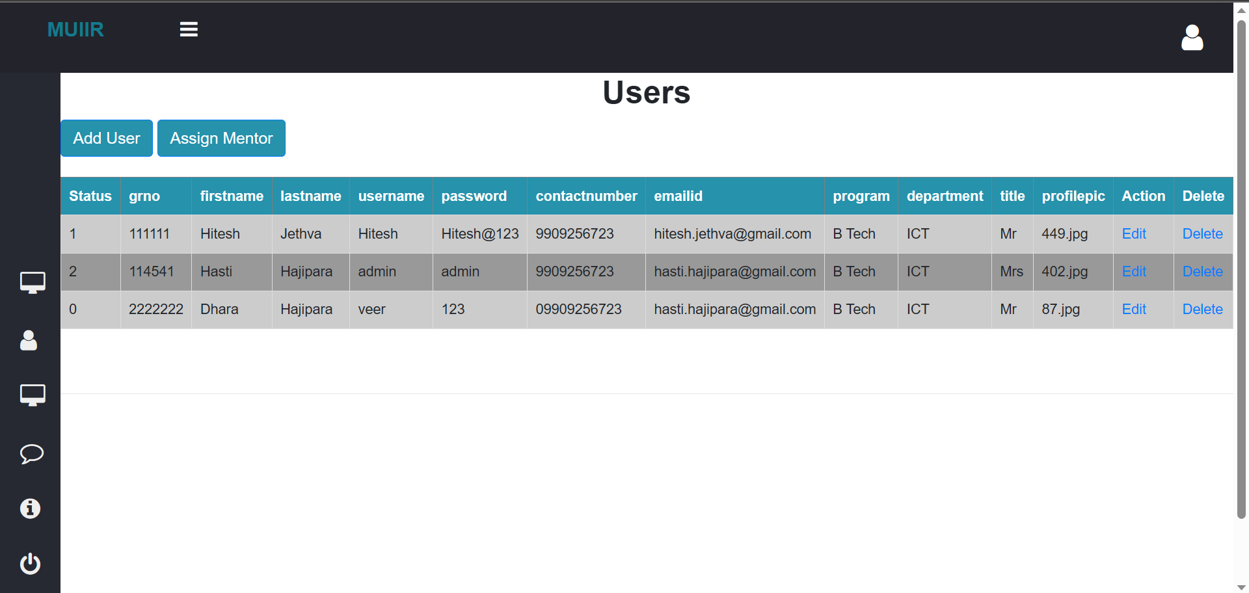

Update user data using this form by admin only

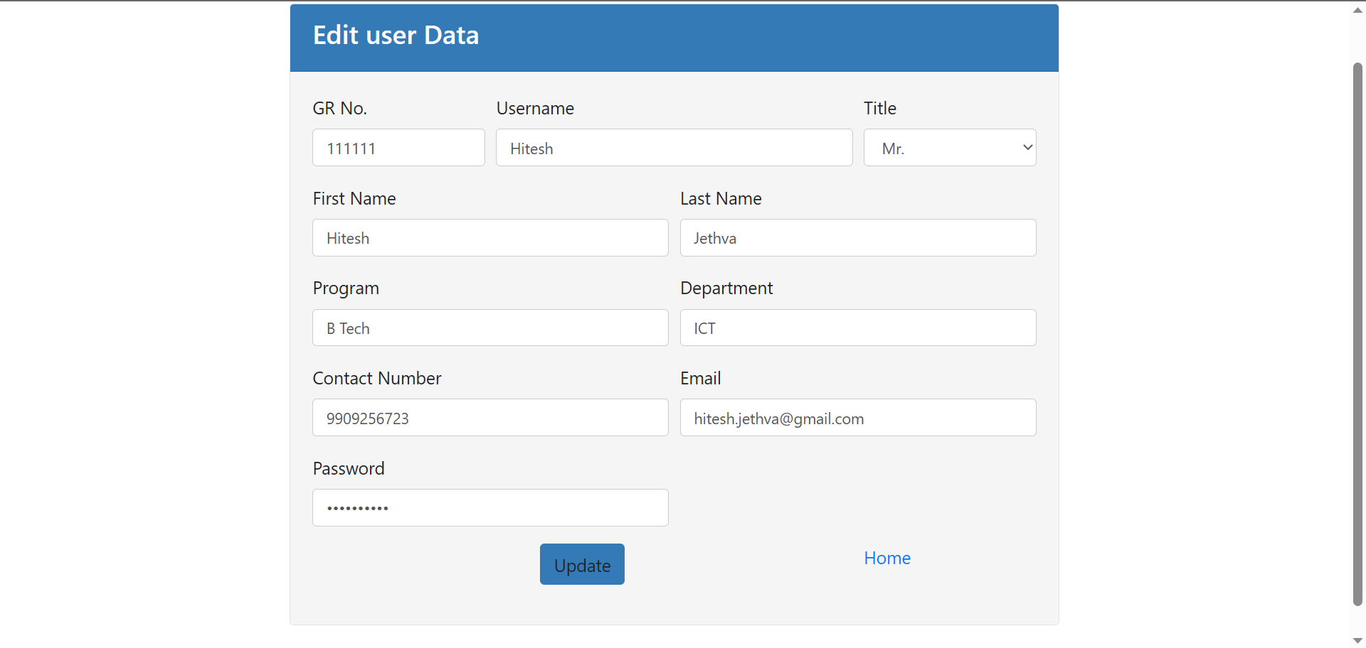

Add Designs ,Update Designs of inventors,delete design of inventor.

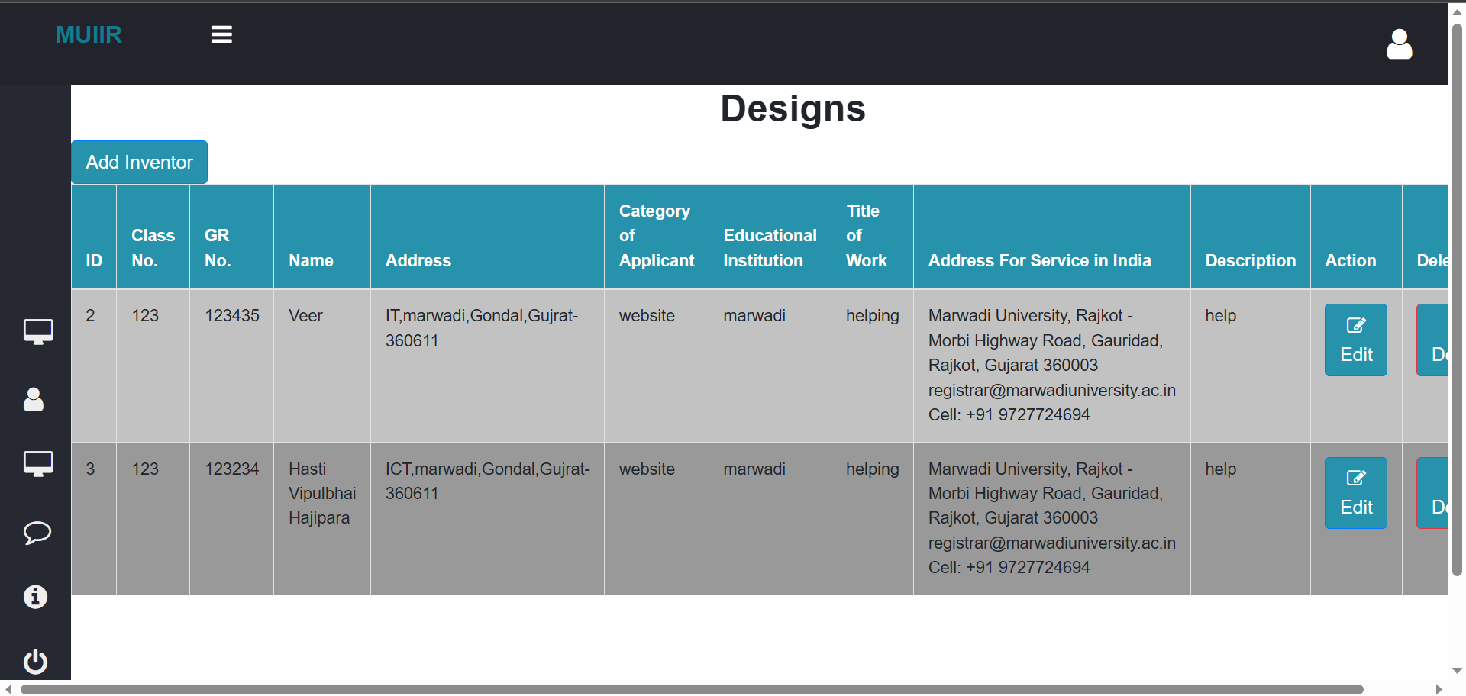

Add Events which store url of event which is store in server side folder,Update events,delete events.

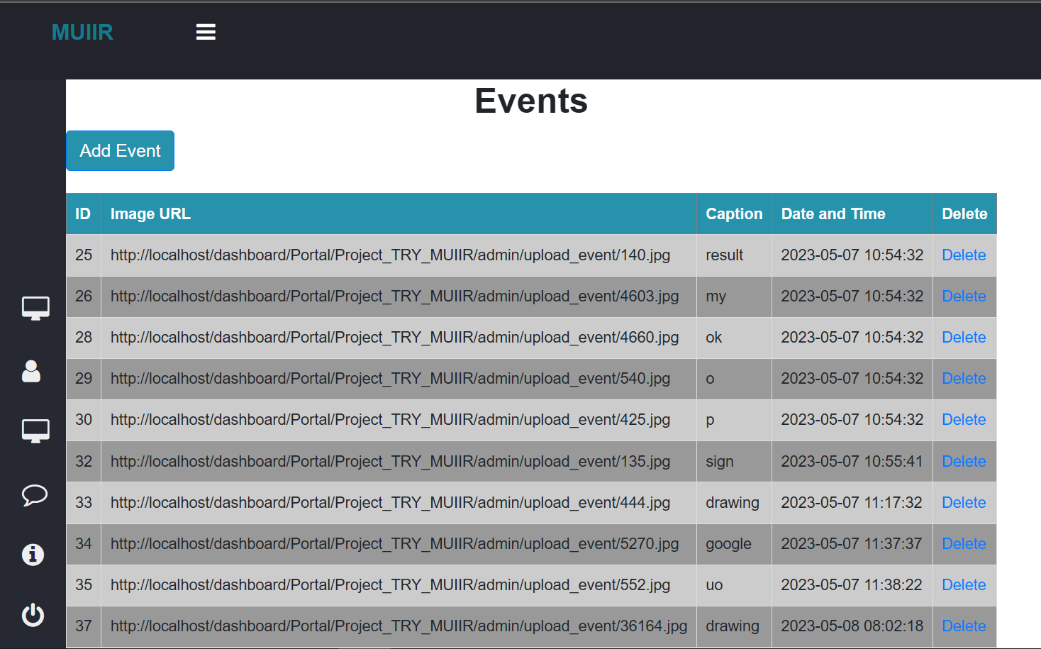

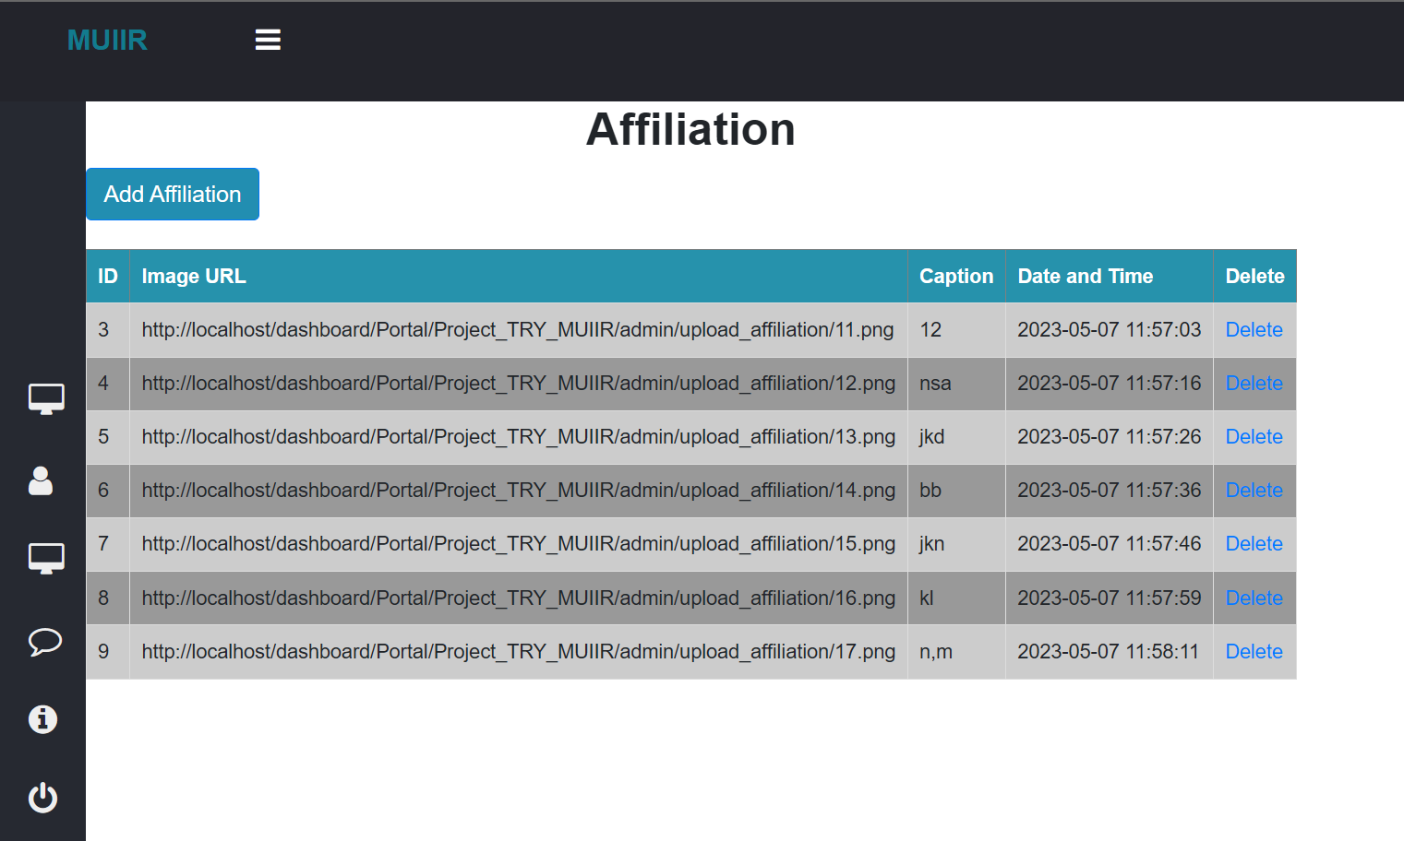

**Conclusion:**

In conclusion, the MUIIR Portal is a centralized platform that effectively manages and streamlines the activities of Marwadi University's Innovation, Incubation and Research Center. The portal offers features like event management, affiliation with different companies, intellectual property rights registration, and facility and service management.

The platform is equipped with separate dashboards for admins, students, and mentors, enabling effective communication and collaboration. It also offers dynamic form options for activities like copyright registration, making the process more efficient and accessible.

Overall, the MUIIR Portal aims to create a seamless and efficient environment for students, mentors, and administrators to collaborate and innovate together. It provides a comprehensive platform for managing all aspects of the center's activities and helps to foster a culture of innovation and research. With its user-friendly interface and efficient features, the MUIIR Portal is a valuable tool for anyone associated with Marwadi University's Innovation, Incubation and Research Center.